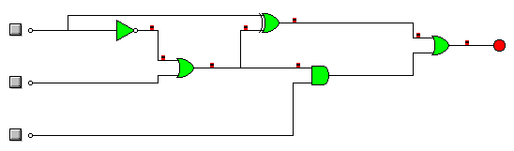

|  |  |  |  |
| --- | --- | --- | --- |
| ***A*** | ***B*** | ***C*** | ***S*** |
| **1** | **1** | **1** | **1** |
| **1** | **1** | **0** | **0** |
| **1** | **0** | **1** | **1** |
| **1** | **0** | **0** | **1** |
| **0** | **1** | **1** | **1** |
| **0** | **1** | **0** | **1** |
| **0** | **0** | **1** | **1** |
| **0** | **0** | **0** | **1** |

***Salida=Ȧ.(Ȧ+B)+(A.B´).A+(Ȧ+B).C***